1. Chairperson room(CSE 1.1)

Chairperson is basically the head of department. Currently the chairperson of CSE department is Professor Dr. Shazia Arshad. The office timings of chairperson is 11 AM to 1 PM from Monday to Friday. Chairperson deals with strong academic leadership. He/She is required to lead, manage and develop the department to ensure it achieves the highest possible standards of excellence in all its activities.

1. Common room for boys

A space for boy’s students to hold meetings, study or simply relax. With the comfortable seating, ample desk area the Common Room is a warm and welcoming place, a perfect blend of fun and function. Mainly after the class ends students prefer not to roam in university but to sit in common room to have some rest as well as if there is some assignment left they can complete that too with internet access in the room and it remains open till 4 PM.

1. Common room for girls

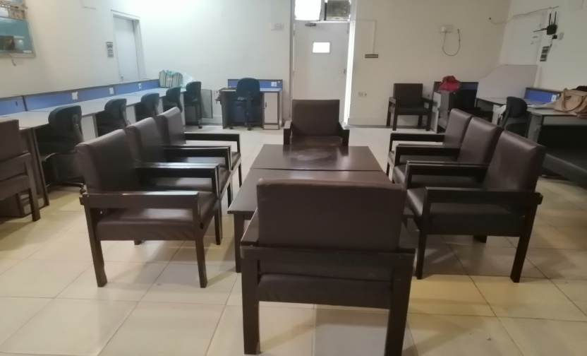

A space for girl’s students to hold meetings, study or simply relax. With the comfortable seating, ample desk area the Common Room is a warm and welcoming place, a perfect blend of fun and function. Mainly after the class ends students prefer not to roam in university but to sit in common room to have some rest as well as if there is some assignment left they can complete that too with internet access in the room and it remains open till 4 PM.

1. Server room (CSE 1.11)

Mr Waqas Butt entertains the students with their problems of internet whether its departmental internet access or university’s internet. If the student of CSE department wants the internet connection of department he/she can access it by giving mac address of his device to the attendant and can access it with the provided passwords of different connections and it remains open till 4 PM.

1. Dr Yasir Saleem’s room(CSE 1.12)

Dr Yasir is the PhD associate professor of CSE department and he entertains his students or faculty members in this room within office timings of 11 AM to 1 PM on Monday, Tuesday and Wednesday .His research interests include Computer networks, Information/Network Security, DSP, Power Electronics, Digital Logic, Embedded System, Image Processing, Simulation and Control system. His teaching courses include Computer Networks, Information Security, and Networking.

1. Admin room(CSE 1.3)

Mr. Anjam Rashid, Mr. Maratab Ali and Mr Kaleem entertain students in admin room. If students face problems relating to lms i.e. Login Id of lms, changing of password etc. they fix them and if students have issues related to registration of the subjects they also entertain them. It remains open till 4 PM.

1. Sir khaldoon kurshid’s lab(CSE 1.6)

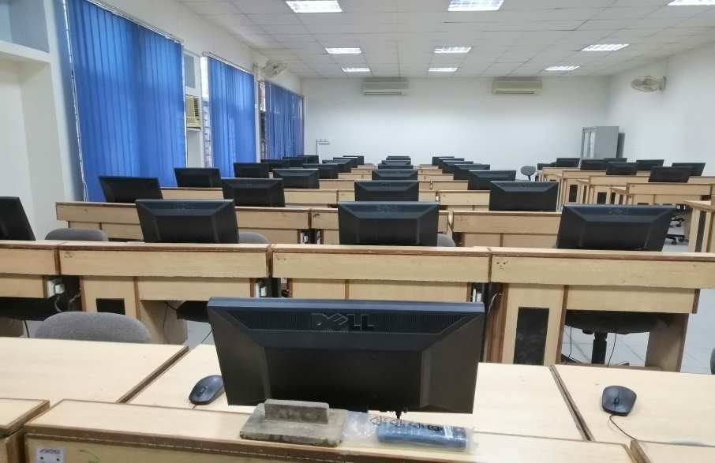

It is a computer lab assisted by Mr. Khalid. Many teachers conduct the practical work of their subjects in this lab. This room is facilitated with the projectors. Mainly presentations by the students are given in this room and also this room is totally available to students for the practice of their practical work. It remains open for students till 4 PM.

1. DR SYED KHALDOON KHURSHID ROOM(CSE 2.12)

Dr khaldoon is assistant professor in department of CSE and he entertains his students and faculty in his room. His research interest is Information Retrieval Systems, Human computer interaction, Computer literacy in common people. His teaching courses are introduction to computing, software engineering, programming language, fundamentals of programming languages, Database systems, and management information system. His office timings are on Monday and Tuesday 2 PM to 4 PM.

1. Dr Junaid Arshad room(CSE 2.10)

Dr Junaid is associate professor in CSE department and he entertains the students and faculty in this room. His research interest is heterogeneous networks and services, Network simulation and modelling, network protocols and security, multi-homed networks focusing on performance, wireless and mobile communication, telecommunication networks. His teaching courses are computer networking, Telecommunication networks and protocols, Advanced computer architecture, internet based software development, Wireless & mobile communication and design and analysis of algorithm. His office timings on Monday till Wednesday are 11 AM to 2 PM and Thursday to Friday is 10 AM to 12 PM.

1. GRADUATE ASSISTANT ROOM

Graduate assistants in CSE department are assistants of the professors, associate professors and assistant professors and they do their graduate studies along with teaching. They take labs of the particular subjects. The GA’s in CSE department are Mr. Muhammad Usman ghanni, Ms Mubaraka Rafique, Ms Dania Batool, Ms Ayesha Jamal, Mr Aown Muhammad, Mr Muhammad Nasir Nawaz, Muhammad Nazam Maqbool and Mr. Muhammad Junaid zaffar.

1. FACULTY ROOM

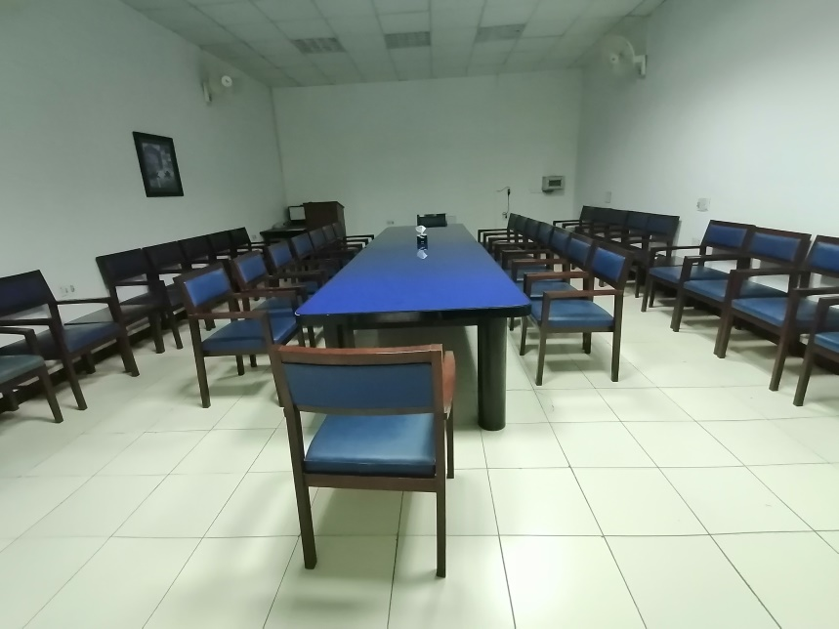

This room is for the faculty of the department of CSE. Meetings among faculty members hold here and in break time faculty can have lunch or tea break here and spend some time with the colleagues.

1. Embedded System lab(CSE 2.3)

This lab is assisted by Mr. Asim rehmat and lab attendant is Mr. Ali. Mr. Asim takes the practical work of Computer Organization and Assembly Language as well as Embedded Systems. This lab is facilitated with soldering kit, Integrated circuits and other programming boards. This lab is available for students till 4 PM.

1. IA & AI Lab (CSE 2.2)

This room is for students of final year of Computer Engineers to take their classes and for then students of 2nd and 3rd year to take classes of Computer Organization and Assembly Language and Embedded Systems.

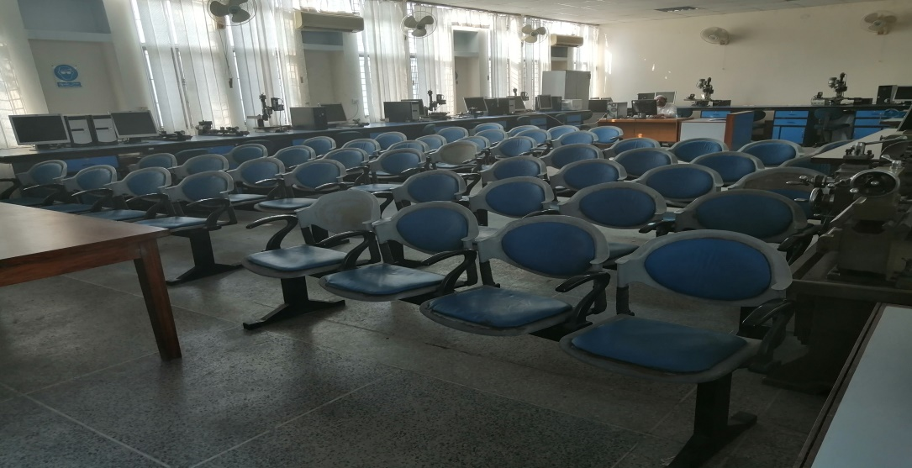

1. CSE 1.7

This room has three teachers Dr Amjad Farooq(Associate professor) and his office timings are on Tuesday and Friday from 9 Am to 11 Am and his research areas are Software Engineering, Semantic Web Engineering, Bioinformatics, Image Processing, Cloud Computing, Dr Sheikh Faisal Rasheed(Assistant professor) and his office timings are on Thursday and Friday from 9 Am to 11 Am and his teaching courses are Machine Learning, Applications of Artificial Intelligence, Document and Content Analysis, Distributed Systems, Object Oriented Programming, Data Mining, Programming Fundamentals, Computing Fundamentals and Dr Fareed Jaffrey and his office timings are on Monday and Tuesday from 12 PM to 1 PM.

1. PhD/Ms Research Lab(CSE 2.5)

This room is for post graduate students. Students spend their spare time doing research related to their PhD or MS projects. They are facilitated with internet for the research work and PCs are also available for them and it is available for the phD/ Ms students till 8 PM.

